Checkpoint 4

CS564

The user starts at a login page, which allows them to either login to the application or register a new account:

If the user registers, that calls a stored procedure to add a tuple to the reader table. If the user is logging in, a stored procedure is called to determine whether their username and password match an existing tuple in the reader table.

2. The user is then taken to a navigation page with several options to navigate.

If the user clicks on the option to browse bought books, we call a stored procedure that returns all the books that they have bought from the bookstore and stores them in a table:

The user will also be able to buy books from tables with a radio button for “Buy”:

This will write back to the database to enter the book in our buys table. It will also write back an indication to the database that the book was bought to prevent others from buying it. We’ll plan to add UI handling to disable the buy button if the book is flagged as sold.

We plan for a similar screen to allow users to favorite books.

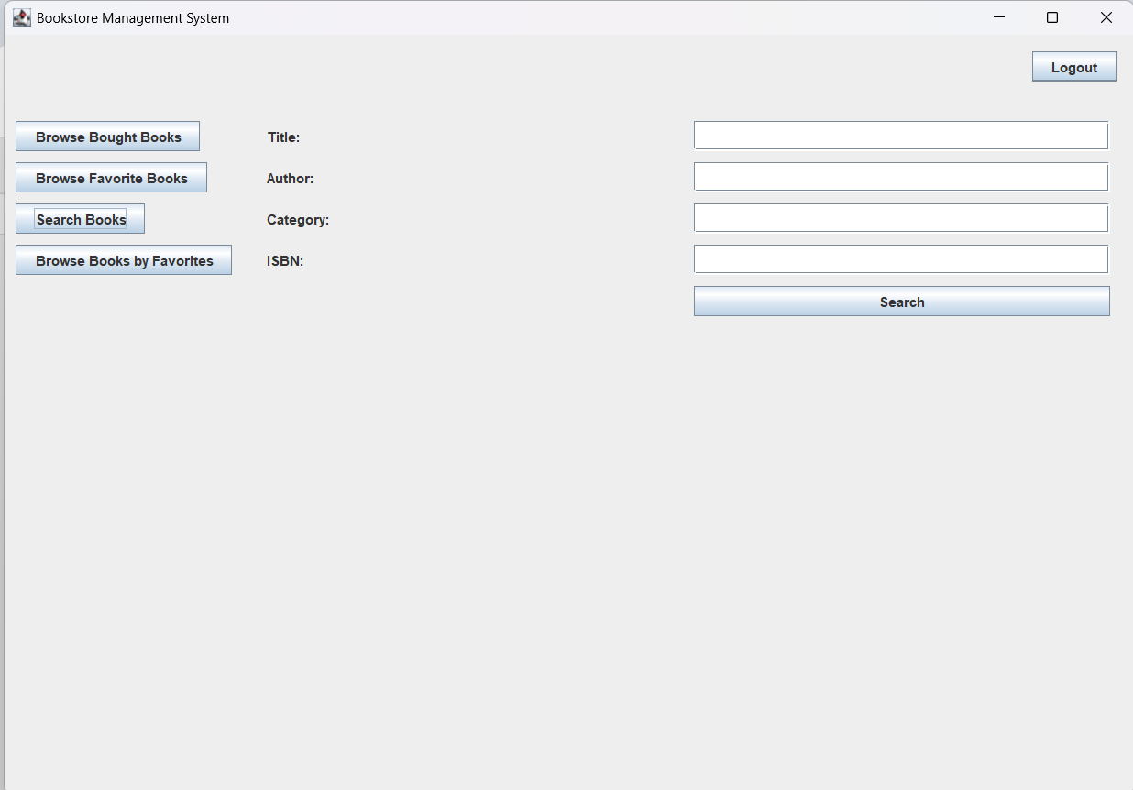

The above UI will allow the user to search various criteria for books to view by entering strings that are passed to a SQL query on the database.

Objectives:

Objectives and Test Cases

1. Allow the user to find books quickly by searching in the application.
   1. First, test searching by the primary key